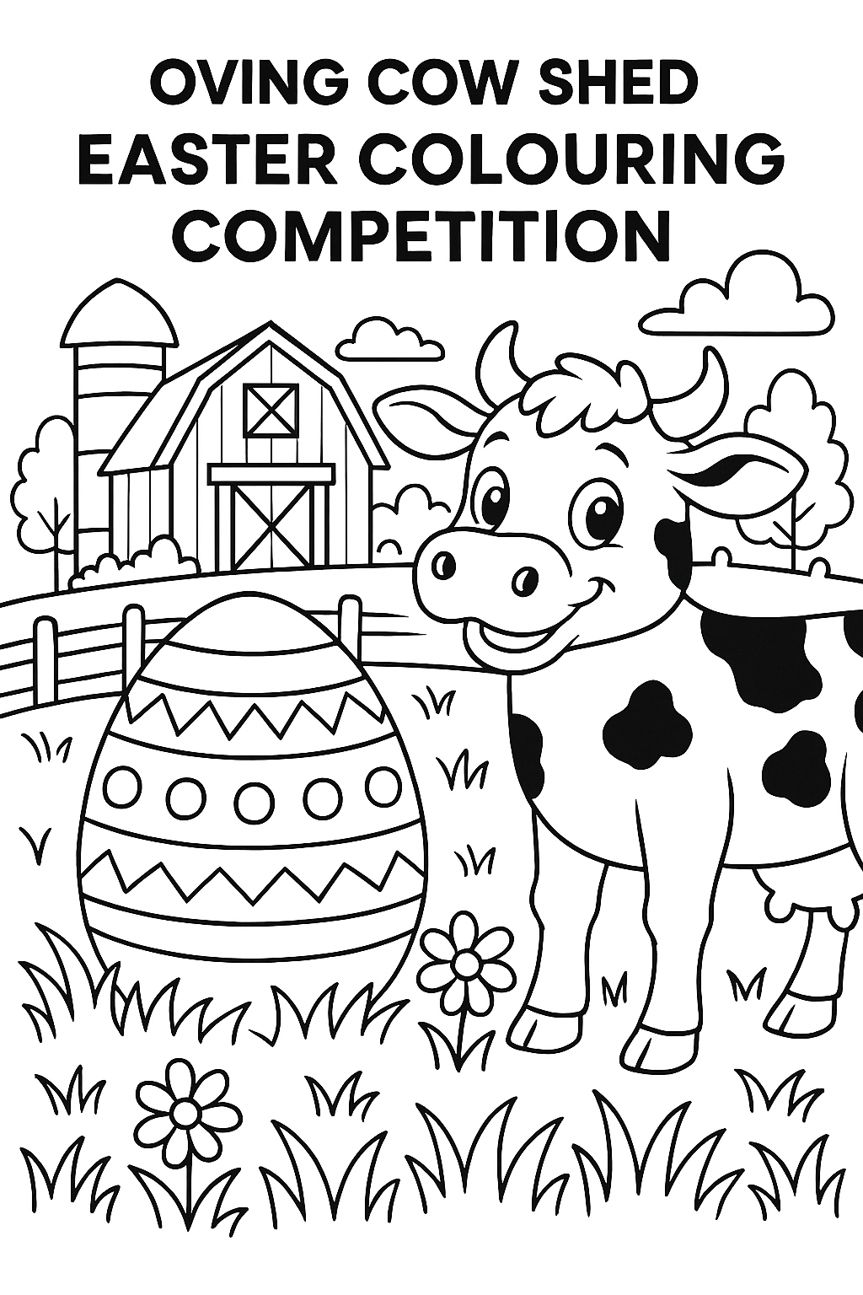
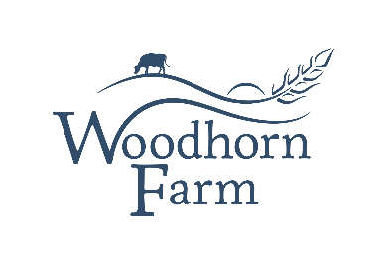
How to Enter:
Pick up a colouring sheet from The Cow Shed or download it from our website. Add your artistic flair, write your name, age and contact details on the back and either pin it to the wall in the Cow Shed or email it to us at: info@woodhornfarm.co.uk
Prizes:
The winner will receive a chocolate Easter egg, a litre of milkshake and a selection of art supplies.

Closing date: Friday 3rd April 2026, GOOD LUCK!

